Test Case: tc002_SPX_Dev5_Crear_Requisicion_Spot_Con_FAD_Tipo_Cobro_CC
Step 1 - Enter username and password and click to button Enter : Credentials Entered
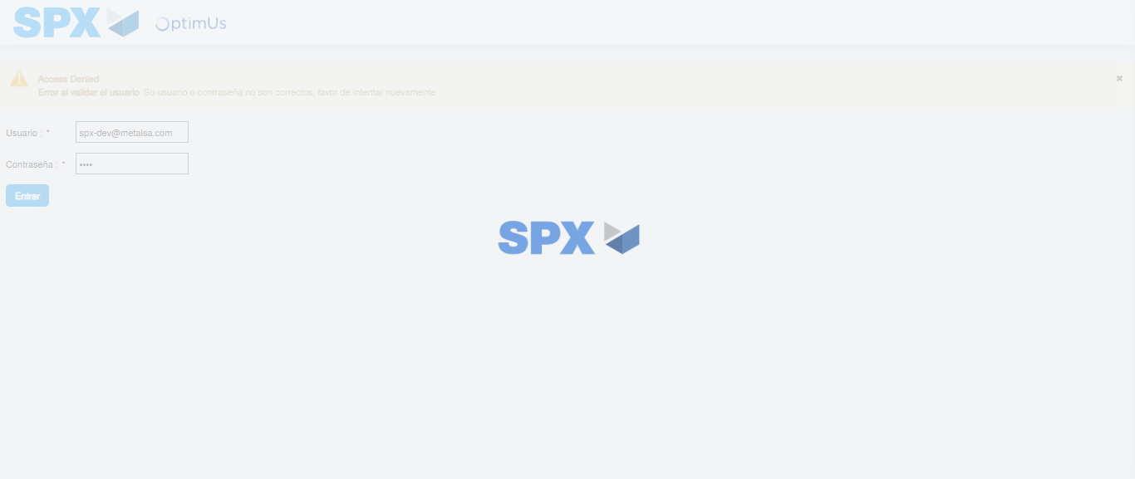Image file-name: QC_Testing-tc002_SPX_Dev5_Crear_Requisicion_Spot_Con_FAD_Tipo_Cobro_CC-1785960185460

Step 2 - Select to UEN and Access to Spot Buy Requisitions : UEN Correctly selected and Correct access
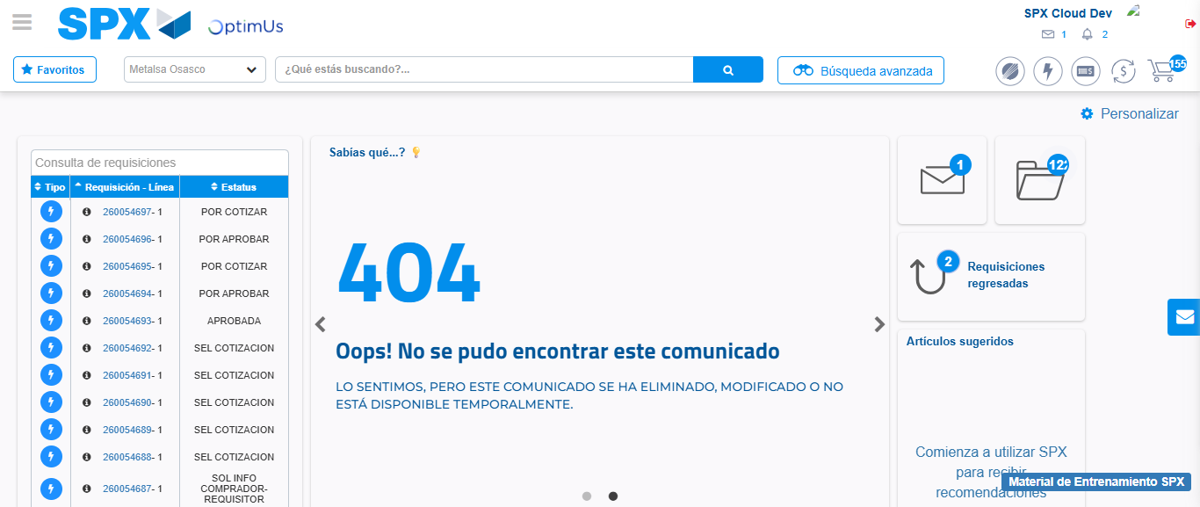Image file-name: QC_Testing-tc002_SPX_Dev5_Crear_Requisicion_Spot_Con_FAD_Tipo_Cobro_CC-1785960217424

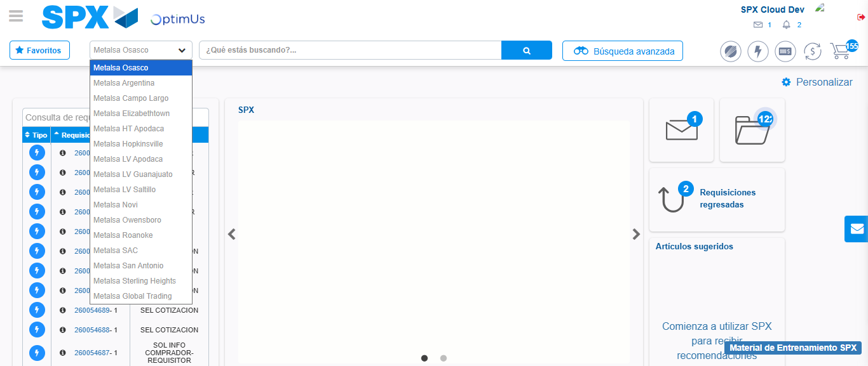Image file-name: QC_Testing-tc002_SPX_Dev5_Crear_Requisicion_Spot_Con_FAD_Tipo_Cobro_CC-1785960220215

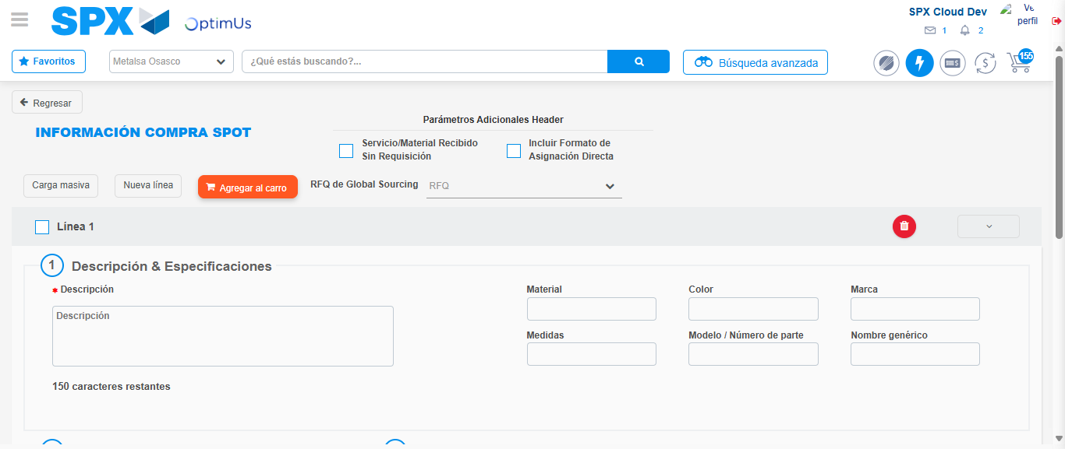Image file-name: QC_Testing-tc002_SPX_Dev5_Crear_Requisicion_Spot_Con_FAD_Tipo_Cobro_CC-1785960232520

Step 3 - Add FAD to Requisition: FAD Successfully Added
Image file-name: QC_Testing-tc002_SPX_Dev5_Crear_Requisicion_Spot_Con_FAD_Tipo_Cobro_CC-1785960232753

Image file-name: QC_Testing-tc002_SPX_Dev5_Crear_Requisicion_Spot_Con_FAD_Tipo_Cobro_CC-1785960232933

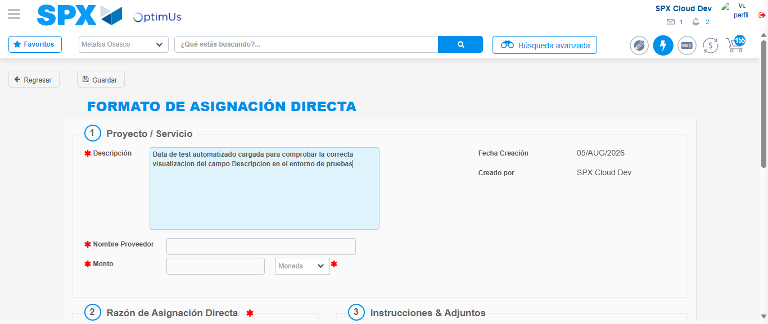Image file-name: QC_Testing-tc002_SPX_Dev5_Crear_Requisicion_Spot_Con_FAD_Tipo_Cobro_CC-1785960235688

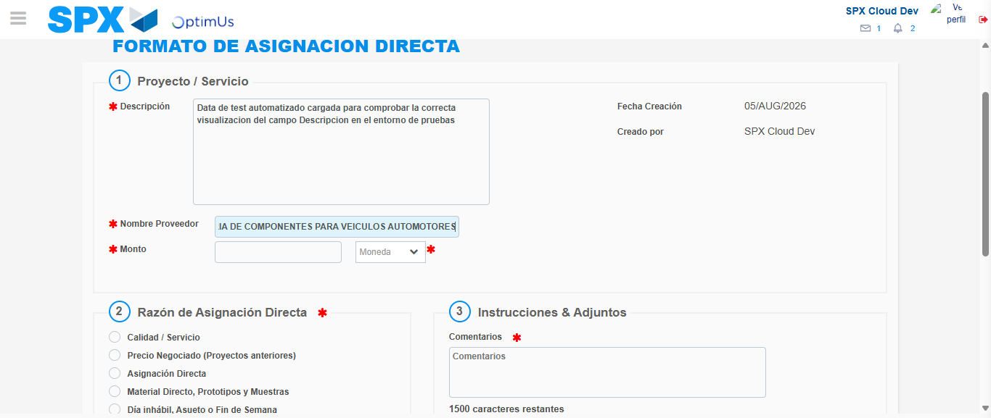Image file-name: QC_Testing-tc002_SPX_Dev5_Crear_Requisicion_Spot_Con_FAD_Tipo_Cobro_CC-1785960245450

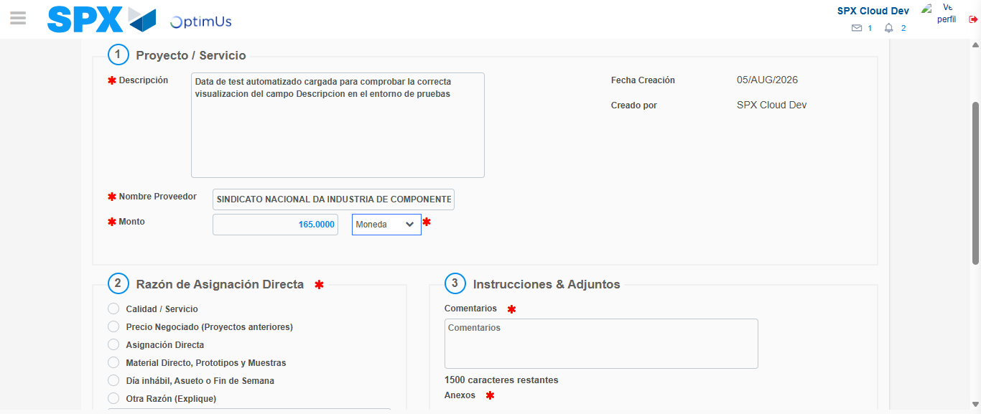Image file-name: QC_Testing-tc002_SPX_Dev5_Crear_Requisicion_Spot_Con_FAD_Tipo_Cobro_CC-1785960245942

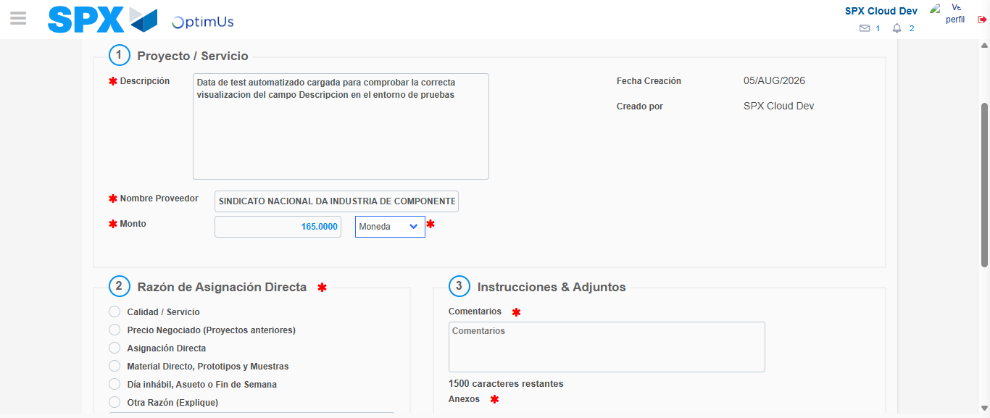Image file-name: QC_Testing-tc002_SPX_Dev5_Crear_Requisicion_Spot_Con_FAD_Tipo_Cobro_CC-1785960246168

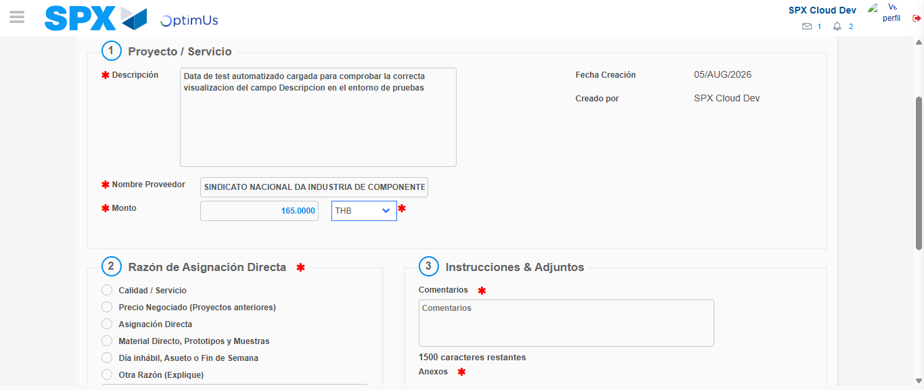Image file-name: QC_Testing-tc002_SPX_Dev5_Crear_Requisicion_Spot_Con_FAD_Tipo_Cobro_CC-1785960246512

Image file-name: QC_Testing-tc002_SPX_Dev5_Crear_Requisicion_Spot_Con_FAD_Tipo_Cobro_CC-1785960246716

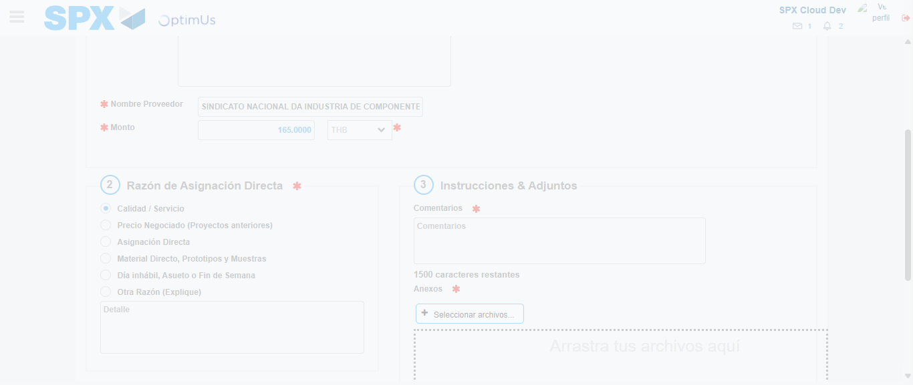Image file-name: QC_Testing-tc002_SPX_Dev5_Crear_Requisicion_Spot_Con_FAD_Tipo_Cobro_CC-1785960248591

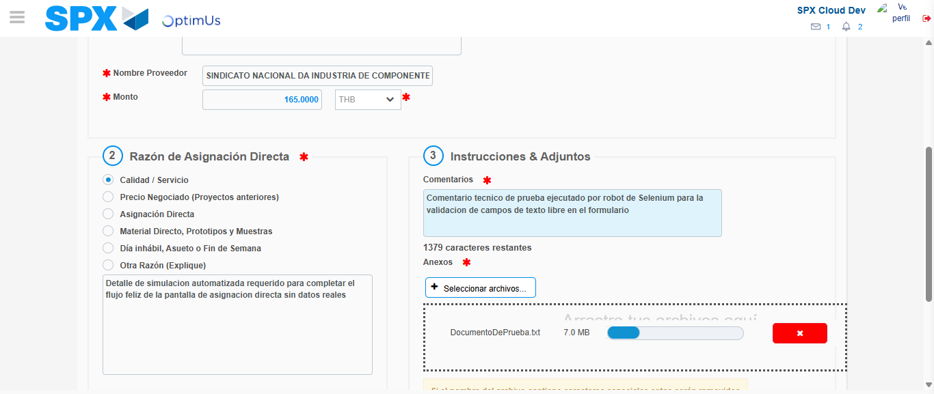Image file-name: QC_Testing-tc002_SPX_Dev5_Crear_Requisicion_Spot_Con_FAD_Tipo_Cobro_CC-1785960260130

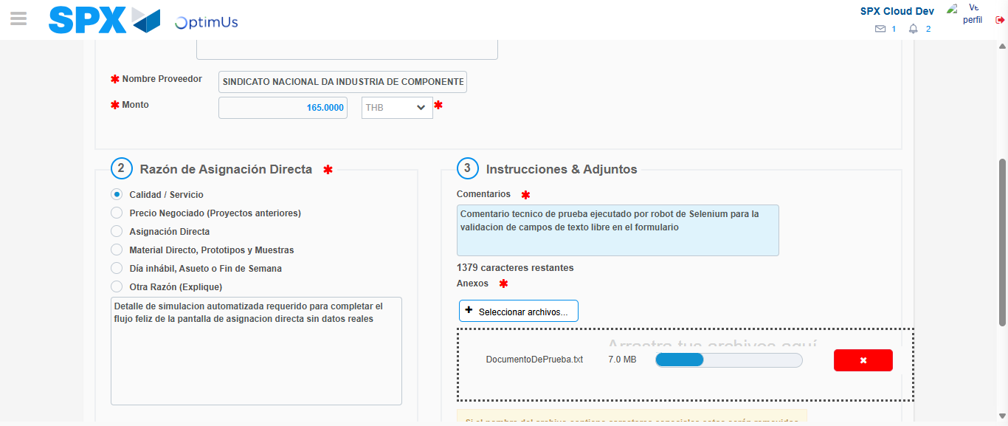Image file-name: QC_Testing-tc002_SPX_Dev5_Crear_Requisicion_Spot_Con_FAD_Tipo_Cobro_CC-1785960260990

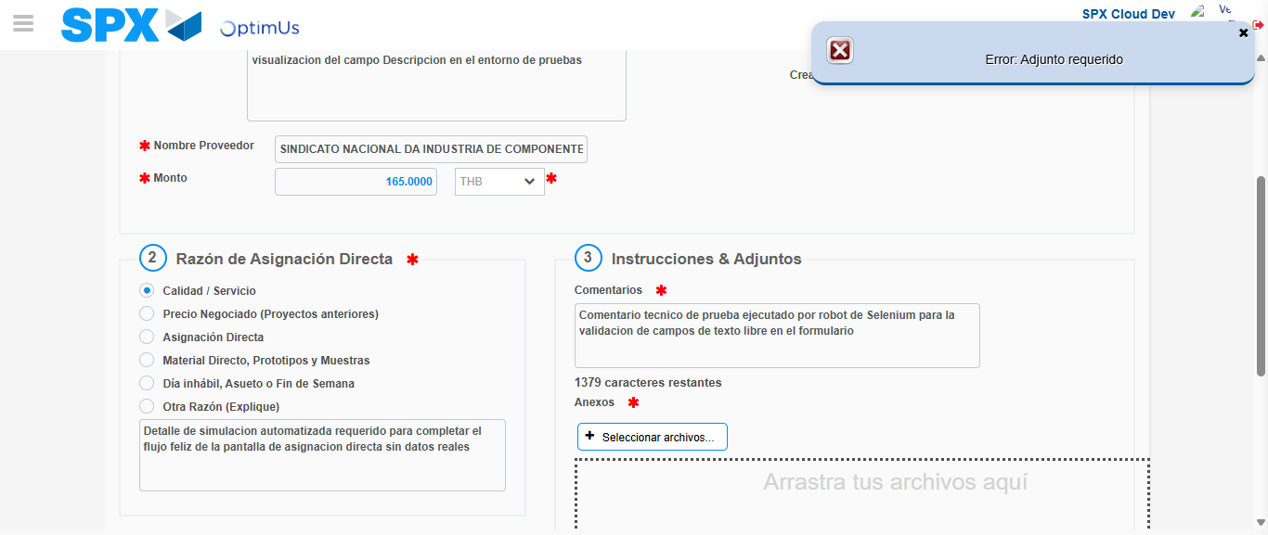Image file-name: QC_Testing-tc002_SPX_Dev5_Crear_Requisicion_Spot_Con_FAD_Tipo_Cobro_CC-1785960262692

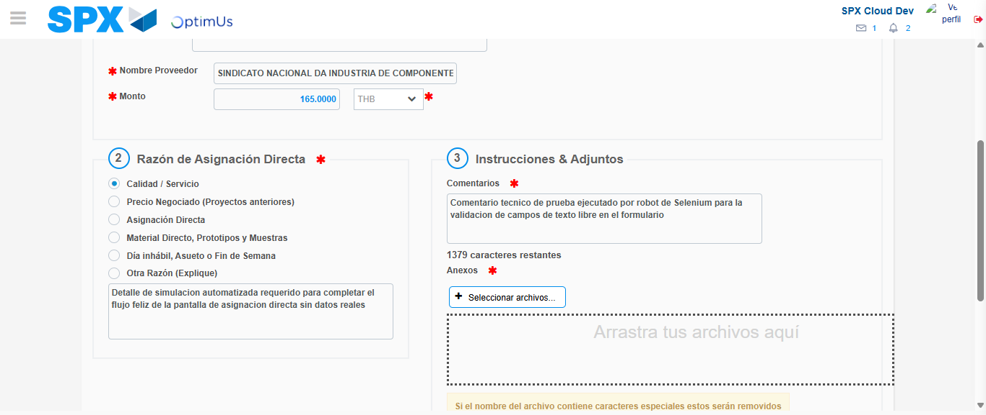Image file-name: QC_Testing-tc002_SPX_Dev5_Crear_Requisicion_Spot_Con_FAD_Tipo_Cobro_CC-1785960273266

Image file-name: QC_Testing-tc002_SPX_Dev5_Crear_Requisicion_Spot_Con_FAD_Tipo_Cobro_CC-1785960273463

Step 4 - Data Capture Spot Buy Requisition: Data captured correctly
Image file-name: QC_Testing-tc002_SPX_Dev5_Crear_Requisicion_Spot_Con_FAD_Tipo_Cobro_CC-1785960232753

Image file-name: QC_Testing-tc002_SPX_Dev5_Crear_Requisicion_Spot_Con_FAD_Tipo_Cobro_CC-1785960232933

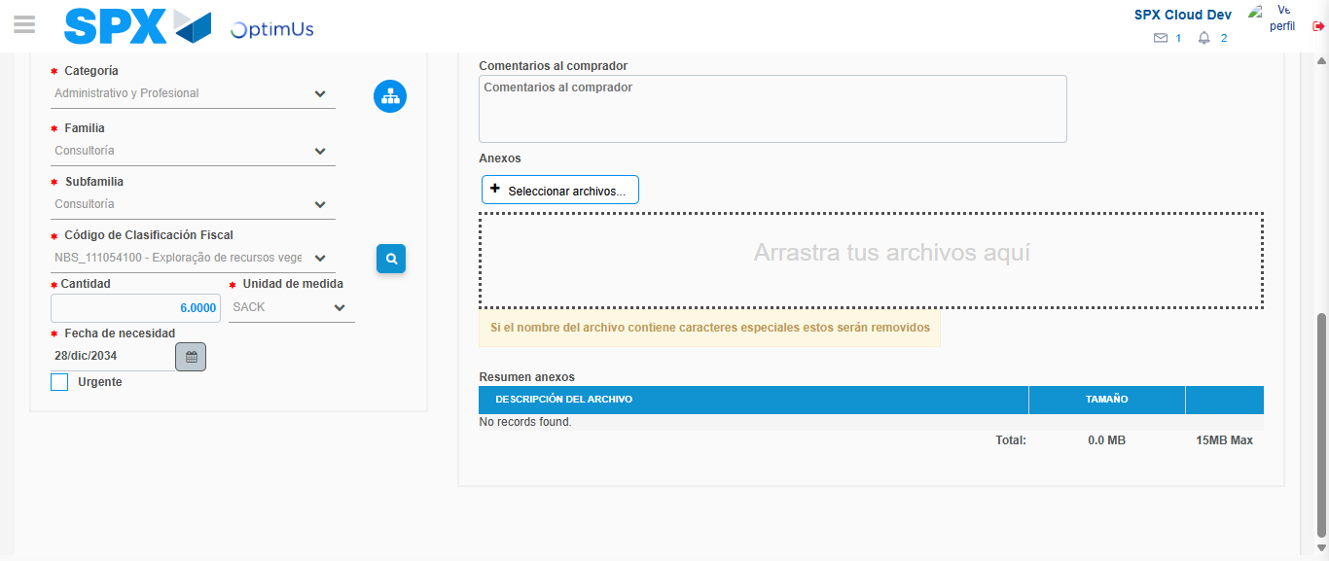Image file-name: QC_Testing-tc002_SPX_Dev5_Crear_Requisicion_Spot_Con_FAD_Tipo_Cobro_CC-1785960291580

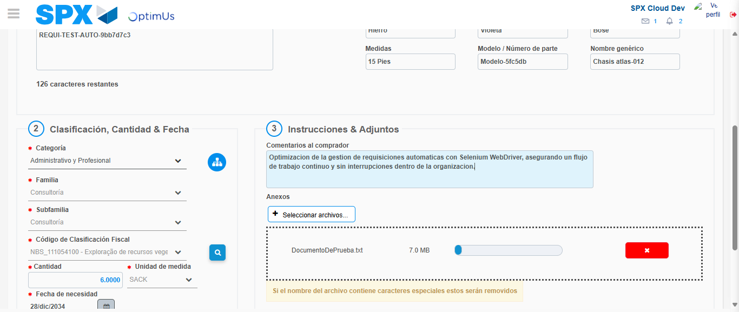Image file-name: QC_Testing-tc002_SPX_Dev5_Crear_Requisicion_Spot_Con_FAD_Tipo_Cobro_CC-1785960292351

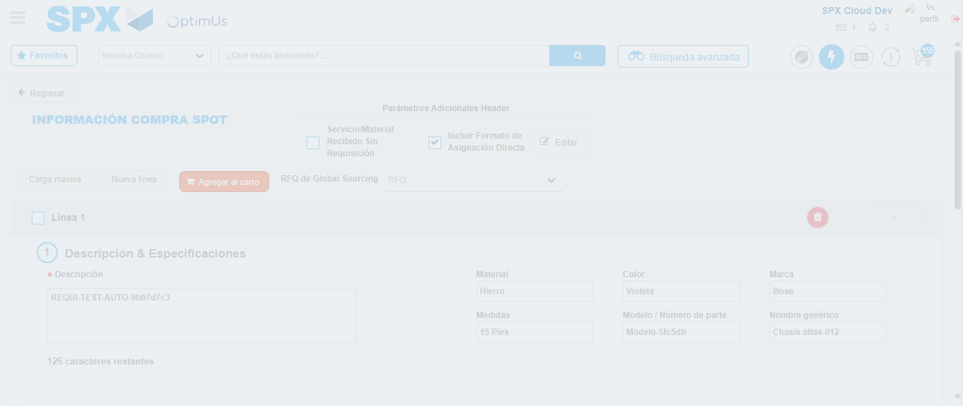Image file-name: QC_Testing-tc002_SPX_Dev5_Crear_Requisicion_Spot_Con_FAD_Tipo_Cobro_CC-1785960312857

Step 8 - Return to Main Page SPX : Return to Main Page SPX
Image file-name: QC_Testing-tc002_SPX_Dev5_Crear_Requisicion_Spot_Con_FAD_Tipo_Cobro_CC-1785960217424

Image file-name: QC_Testing-tc002_SPX_Dev5_Crear_Requisicion_Spot_Con_FAD_Tipo_Cobro_CC-1785960220215

Image file-name: QC_Testing-tc002_SPX_Dev5_Crear_Requisicion_Spot_Con_FAD_Tipo_Cobro_CC-1785960232520

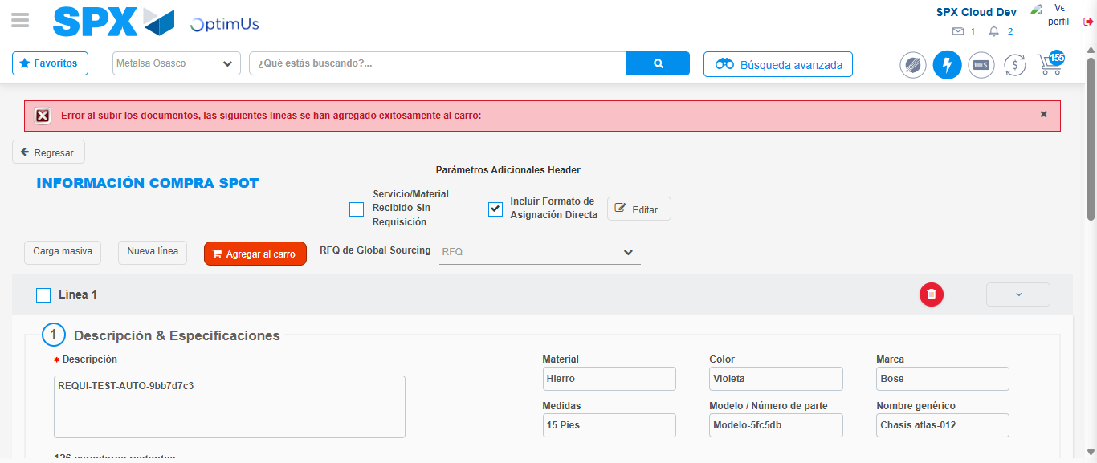Image file-name: QC_Testing-tc002_SPX_Dev5_Crear_Requisicion_Spot_Con_FAD_Tipo_Cobro_CC-1785960315107

Image file-name: QC_Testing-tc002_SPX_Dev5_Crear_Requisicion_Spot_Con_FAD_Tipo_Cobro_CC-1785960315288

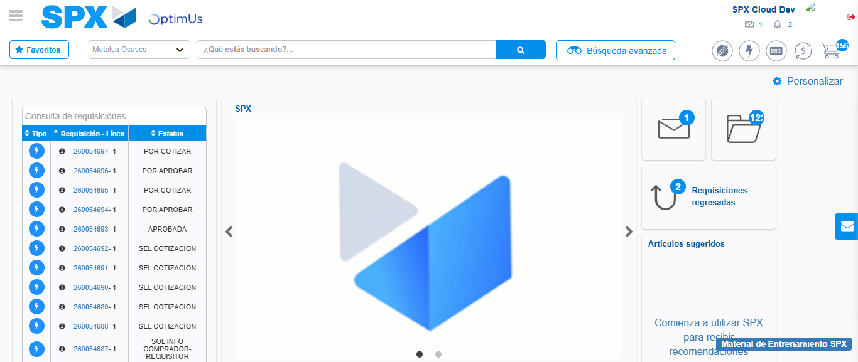Image file-name: QC_Testing-tc002_SPX_Dev5_Crear_Requisicion_Spot_Con_FAD_Tipo_Cobro_CC-1785960336468

Step 9 - Log Out : Log Out SPX
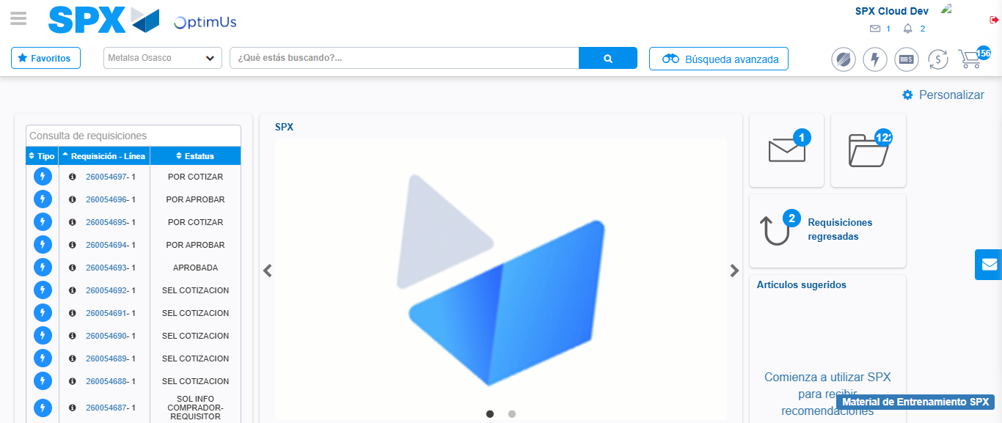Image file-name: QC_Testing-tc002_SPX_Dev5_Crear_Requisicion_Spot_Con_FAD_Tipo_Cobro_CC-1785960336797

